Optimizing Machining Process Parameters using NSGA-II

Varun Gupta

Department of Mathematics

Indian Institute of Technology, Kharagpur

18MA20050

Term Project – MT21104

**Abstract –**

The Non-Dominated Sorting Genetic Algorithm i.e. NSGA-II (II because it is different from the initial implementation of NSGA and one of the main differences is its elitism nature) is applied to optimize the machining process parameters. This paper reviews the application of NSGA-II, classified as one of the Multi-Objective Genetic Algorithm (MoGA) techniques, to optimise for minimum quantity lubrication assisted milling process. NSGA-II is a well-known, fast sorting, and elite multi-objective genetic algorithm. Process parameters can be improved by selecting suitable parameters. Calculated values are validated with typical data from the literature. Unlike the single objective optimization technique, NSGA-II simultaneously optimizes each objective without being dominated by any other solution. Minimum quantity lubrication method is very effective for cost reduction and promotes green machining. The effects of minimum quantity lubrication and machining parameters are examined to determine the optimum conditions with minimum surface roughness and minimum power consumption. Empirical models are developed to predict surface roughness and power of machine tool effectively and accurately using response surface methodology and multi-objective optimisation genetic algorithm. Comparison of results from response surface methodology and multi-objective optimisation genetic algorithm depict that both

measured and predicted values have a close agreement. *This model could be helpful to select the best combination of end-milling machining parameters to save power consumption and time, consequently, increasing both productivity and profitability.*

***Keywords -***

Response surface methodology (RSM), Box–Behnken design, multi-objective genetic algorithm, end-milling, machining parameters, surface roughness, power consumption.

**Introduction-**

Machining Operation is a very important process in the manufacturing industry and generally described as a mechanical process of materials cutting by specified tools. End-milling operation is extensively used in automotive, aerospace industries and many other industrial sectors where quality and precision are important factors. Surface finish or surface roughness is a vital parameter for measuring the accuracy, fatigue behaviour, creep and corrosion resistance of various materials. By considering surface roughness as a performance measure, it helps to predict the performance of machining parameters on material cutting. It is very important to select the process parameters to obtain maximum milling quality.

In metal cutting operations, the most important factor is the recognition and formulation of the operating conditions, such as process variables. Furthermore, the selection of the proper machining parameters can help in mediation between cost and quality of the material. Surface roughness of material is an important factor required to evaluate the product quality when machining under various parameters. It is influenced by several machining parameters which are required to optimise to achieve the optimum surface finish of material. Moreover, the combined effect of machining parameters is also important for end-milling operation. Power consumption has also become a major concern for manufacturing industries. Improvement on power consumption will provide great benefit to the industry by reducing the energy cost as well as contribute towards alleviating the problems of air pollution and energy crisis. The energy efficiency of machining process depends on the machine tool, cutting conditions as well as the applied values of process parameters. Therefore, different researchers have made contributions towards efficient utilisation of power consumption by optimising the machining parameters. Genetic algorithm is considered as a powerful tool which have been used for the optimisation of machining parameters. Minimizing the production time, minimizing production cost and minimizing the surface roughness which in turn all maximizes the profit rate are the three conflicting machining operation objectives that need an intensive consideration in the real machining application. Single objective optimisation does not preach the industrial problems and provide only specific solution for single response and its main disadvantage is that it doesn’t consider other critical response of the process. To solve this issue, various approaches have been applied for multi-objective optimisation using priority techniques to make the multi-objectives in the scalar form to solve as a single objective function. Besides these priority multi-objective techniques, the non-dominated solutions are dealt with using multi-objective genetic algorithm (MOGA) where optimisation objectives are considered simultaneously. The pareto optimal solutions are obtained to investigate the combined effect of the performance parameters. Several Pareto optimal points can simultaneously obtain with an even distribution solution from the Pareto optimal sets that exist which can reduce the production time and cost. Therefore, this study seeks to optimise the effects of different machining parameters on surface roughness of AISI 1045 material and power consumption during end-milling operation, using NSGA-II.

So, our aim is to optimise the milling process parameters to get the optimum situation of production rate, operational cost and profit rate. To do that we have to consider the effects of the three (3) variables given below on the milling process.

* Feed Rate
* Spindle Speed
* Depth of Cut

Estimation of the optimum parameters for machining operation has been a great concern of manufacturing industries, because of the machining cost which plays an effective role in products manufacturing. The novelty of this innovative study includes the integration of low-cost power measurement system, MQL technique with end-milling process and multi-objective optimisation of machining parameters using MOGA approaches especially NSGA-II.

**Overview of NSGA-II**

NSGA-II is one of the most popular multi objective optimization algorithms with three special characteristics, fast non-dominated sorting approach, fast crowded distance estimation procedure and simple crowded comparison operator. Generally, NSGA-II can be roughly detailed as following steps.

**Step 1: Population initialization –**

Initialize the population based on the problem range and constraint.

**Step 2: Non-dominated sort**

Sorting process based on non-domination criteria of the population that has been initialized.

**Step 3: Crowding distance**

Once the sorting is complete, the crowding distance value is assigned front wise. The individuals in population are selected based on rank and crowding distance.

**Step 4: Selection**

The selection of individuals is carried out using a binary tournament selection with crowded-comparison operator.

**Step 5: Genetic Operators**

Real coded GA using simulated binary crossover and polynomial mutation.

**Step 6: Recombination and selection**

Offspring population and current generation population are combined and the individuals of the next generation are set by selection. The new generation is filled by each front subsequently until the population size exceeds the current population size.

**METHODOLY**

Experimental setup

For model development, a careful planning and DoEs are essential. Therefore, a detailed study was conducted to determine how different end-milling machining parameters affect the surface roughness and power approaches consumption responses. Three machining parameters, such as feed rate, spindle speed and depth of cut, were selected for experimentation. End-milling experiments

were performed on CNC milling machine. AISI 1045, hardness 84 on HRB scale, was used as a workpiece or sample material to examine the surface roughness. Each of AISI 1045 sample used for experimentation has length, width and thickness of 8, 6 and 0.5 inches, respectively. The tool used in this experimentation was coated tungsten carbide end mill cutter with cutting edges and diameter of 6 and 10 mm, respectively.

**Design of Experiment**

Three different relevant machining factors were selected for this study. These parameters include feed rate, spindle speed and depth of cut. Parameters were coded with different levels as independent variables: feed rate (A), spindle speed (B) and depth of cut (C). In the reference publication the authors have calculated the functions to determine the value of surface finish and power as a function of the three variables mentioned. It is given as follows:

Ra = +2.31 + 0.66A – 0.12B – 0.15C – 0.11AB + 0.097AC + 0.15BC - 0.17A2 – 0.47B2 – 0.17C2

P = +1039.38 + 7.50A + 127.00AB + 35.50C – 1.25AB + 3.75AC + 1.25BC

Where,

A = Feed Rate

B = Spindle Speed

C = Depth of Cut

Ra = Surface Roughness

P = Power

An important point to be considered here is that we have used the formula from the reference publications as they have evaluated it using the BBD based on RSM model which suggested the quadratic model for both the surface roughness and power by using the required data.

Hence, we would be using these functions to optimize the values of both the objectives on the basis of the given variables and in the constraints as provided by the study to ensure correct results, which would be in accordance to the study and could be easily verified from it. The constraints for the given variables are as follows:

20 <= Feed rate <= 30 or 20 <= A <= 30

250 <= Spindle Speed <= 550 or 250<=B<= 550

0.20<=Depth of Cut<=1.4 or 0.20<=C<=1.4

Here we discuss some of the pointers given by the RSM model to get some intuition about the process parameters used-

* RSM–based model analysis was performed to generate predicted responses for given machining factors which suggested quadratic model for both the surface roughness and power.
* At the middle level of spindle speed and higher level of feed, maximum surface roughness is observed.
* It is general consensus from the previous studies that surface roughness is directly proportional to feed rate and inversely proportional to depth of cut and spindle speed.
* It is observed that the power is directly proportional to spindle speed, feed rate and depth of cut.
* It is pertinent to mention that width of cut has also significant effect on the cutting power. However, in this study, width of cut values has been kept as a constant.

**Multi-objective optimisation**

Milling operation is a critical machining process and it is difficult to minimise or maximise all the objectives simultaneously. MOGA is extensively used in the literature for the optimisation of conflicting machining parameters. In the normal genetic algorithm, a scattered population of genomes around the search space is taken and fitness value is evaluated. The best population results are retained and new population is created, incorporating the genetic operators (crossover and mutation) to attain diverse solution results. MOGA is similar to normal GA, except the search space is vast to optimise the multiple fitness parameters simultaneously.

Pareto Front is considered as two dimensional as we are considering to optimise two objectives simultaneously. NSGA-II is used to get a Pareto-Optimal front to solve the two-objective optimization problem. BBD based on RSM model was developed and NSGA-II is used to optimize the process parameters. To achieve the overall fitness result of both objectives and under the given constraints, the results are obtained using Pareto optimal solution. The Pareto front was plotted to identify the combined effect of power and surface roughness, considering the machining parameters of the proposed goal attainment MOGA.

An NSGA-II Algorithm was used to optimize the functions mentioned above. The algorithm attempts to optimize both the objectives while being in the required constraints. It allows changes in the new population on the basis of elitism and checks in all the parents and children for the new parents and fills the population on available space and employs the crowded selection, mutation and crossover operator to select those candidates which could be the representative of the area of candidates where it belongs so that the diversity in the coming generations is always maintained which is one of the main goals of MOOP.

**NSGA Algorithm**

Nature-inspired optimization algorithms have become useful in solving difficult optimization problems in different disciplines. Since the introduction of evolutionary algorithms several studies have been conducted on the development of metaheuristic optimization algorithms. The NSGA-II model proceeds in the following manner:

1. Population is initialized based on the problem range and constraints.
2. Then the initialized population is sorted based on non-domination, which is as follows:

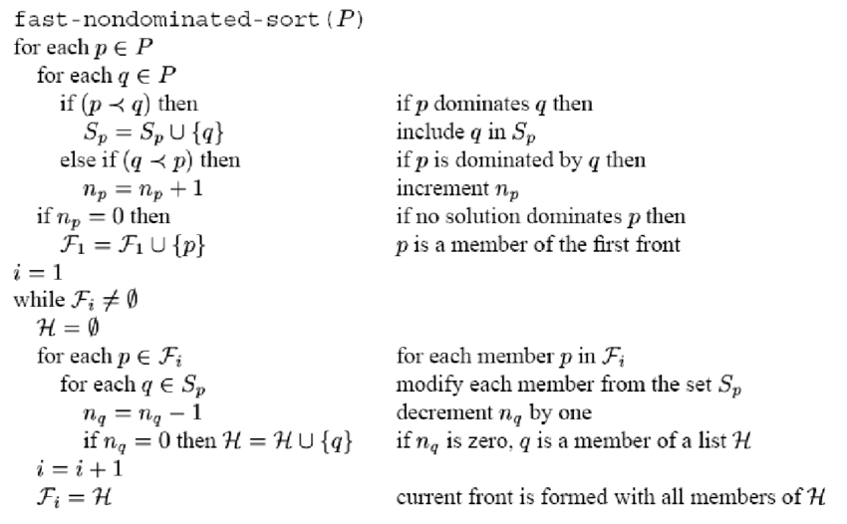

It utilizes the information about the set that an individual dominates and number of individuals that the that same individual. This way we also assign the fitness to each individual.

1. Once the sorting is complete, then all the individuals in the population are assigned a crowding distance. It is assigned front wise. The basic idea behind the crowding distance is finding the Euclidean Distance between each individual in a front based on their m objectives in the m dimensional hyper space. The individuals in the boundary are always selected since they have infinite distance assignment which is due to the reason to increase the diversity in the generation.
2. Now the individuals in the population are selected using the **crowded-comparison-operator**. It is carried based on:

* Non-domination rank
* Crowding Distance

The individuals are selected by using a binary tournament selection with crowded-comparison-operator.

1. Real-coded GA’s use **Simulated Binary Crossover (SBX)** operator for crossover and **polynomial mutation**.

Simulated Binary Crossover. Simulated binary crossover simulates the binary crossover observed in nature and is give as below.

c1, k = 1/2 [(1 − βk) p1, k + (1 + βk) p2, k]

c2, k = 1/2 [(1 − βk) p1, k + (1 + βk) p2, k]

where ci,k is the ith child with kth component, pi,k is the selected parent and βk (≥ 0) is a sample from a random number generated having the density

p(β) =1/2 (ηc + 1) βηc, if 0 ≤ β ≤ 1

p(β) =1 2 (ηc + 1) 1 βηc+2, if β > 1

This distribution can be obtained from a uniformly sampled random number u between (0, 1). ηc is the distribution index for crossover. That is

β(u) =(2u) 1/(η+1)

β(u) = 1/ [2(1 − u)]1/(η+1)

The crossover probability is kept around 0.9 for the SBX crossover in this algorithm.

Polynomial Mutation

ck = pk + (puk − plk)δk

where ck is the child and pk is the parent with puk being the upper bound on the parent component, plk is the lower bound and δk is small variation which is calculated from a polynomial distribution by using

δk =(2rk)1/ηm+1 − 1, if rk < 0.5

δk =1 − [2(1 − rk)]1/ηm+1 ,if rk ≥ 0.5

rk is a uniformly sampled random number between (0, 1) and ηm is mutation distribution index.

The mutation probability is kept around 1/N where N denotes the number of decision variables which here would be N = 3.

1. The offspring population is combined with the current generation population and selection is performed to set the individuals of the next generation. Since all the previous and current best individuals are added in the population, elitism is ensured. Population is now sorted based on non-domination. The new generation is filled by each front subsequently until the population size exceeds the current population size. If by adding all the individuals in front Fj the population exceeds N then individuals in front Fj are selected based on their crowding distance in the descending order until the population size is N. And hence the process repeats to generate the subsequent generations. Then this follows till to required number of generations.
2. The whole process of NSGA-II could be depicted as follows:

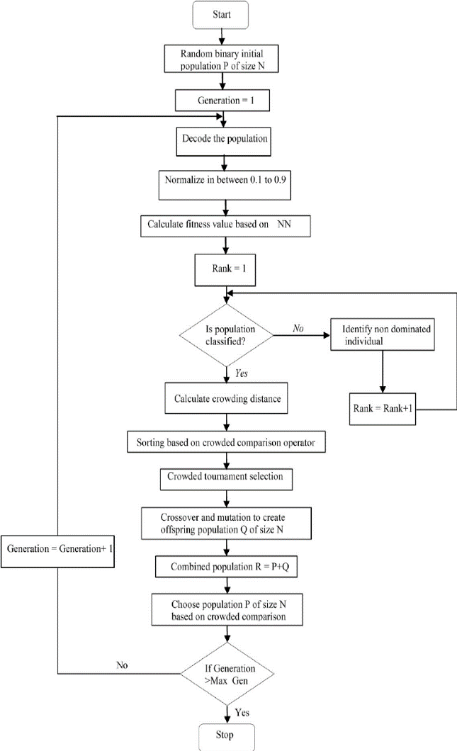

**Results and Discussion**

The results are obtained using Pareto Solution. The Pareto front is plotted to identify the combined effect of power and surface roughness. The pareto front can be shown as follows:

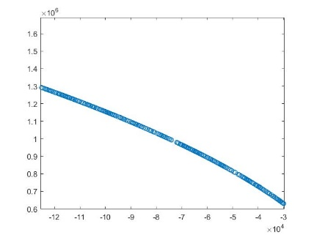

This is very similar to the pareto front obtained by using different MOGA on the same objectives.

All the analysis and calculations were done in MATLAB. The codes related to the problem have been given to reassess the conditions and parameters evaluated. 5000 random individuals were generated in 500 generations to obtain this pareto front which corresponds to both the objective functions. These were corresponding to the three variables and two objectives that needed to be optimised.

It has been found that the proposed NSGA-II provided better results in terms of surface roughness, when compared with other methods. The literature suggests that the value of

**Conclusion**

Experiments were performed on CNC end-milling machine using coated tungsten carbide end-mill tool under different combinations of machining parameters: feed rate, spindle speed and depth of cut. Ultimate objective of this study is to determine the optimum combination of parameters i.e. the pareto optimal front for minimum surface roughness and minimum power milling process. A quadratic model was suggested by RSM for both surface roughness and power. NSGA-II was used for the multi-objective optimisation of response under same cutting conditions. The following conclusion can be drawn:

1)NSGA-II provided better results in terms of surface roughness, when compared with other methods, such as RSM and simple MOGA. The minimum surface roughness was obtained, using proposed algorithm with depth of cut of 1.4 mm

2) A non-dominated solution set has been obtained and this shows that the algorithm is suited for getting Pareto frontier in optimization of process parameters and the set obtained from NSGA-II outperformed the other MOGA methods.

3)The results of both RSM and NSGA-II coincide is some parameters, depicting the accuracy of the experimentation and precision of genetic algorithm used. Therefore, it is evident that the proposed model can be used to select parametric levels for end milling operation for optimal machining.

4)This current study has industrial application in terms of saving cost of electricity and achieving defect free parts. Importantly, the results obtained from multi-objective optimisation tends to improve productivity and reduce the power consumption of the machine shop.

5)NSGA-II as part of MoGA is a popular and reliable technique that can be used in optimizing the process parameters of multiple machining performances.

**References**

* Overview of NSGA-II for Optimizing Machining Process Parameters,

Yusliza Yusoff, Mohd Salihin Ngadiman, Azlan Mohd Zain

* Multi-objective optimisation for minimum quantity lubrication assisted milling process based on hybrid response surface methodology and multi-objective genetic algorithm Jabir Mumtaz, Zhang Li, Muhammad Imran, Lei Yue, Mirza Jahanzaib, Shoaib Sarfraz, Essam Shehab, Sikiru Oluwarotimi Ismail, Kaynat Afzal
* A Fast Elitist Multiobjective Genetic Algorithm: NSGA-II, Kalyanmoy Deb, Amrit Pratap, Sameer Agarwal, and T. Meyarivan.

**Acknowledgment**

The authors want to thank their Genetic Algorithm Professor Nirupam Chakrobarty for giving them the opportunity to work on this paper and for motivating us investigate genetic algorithms in a more practical setting.